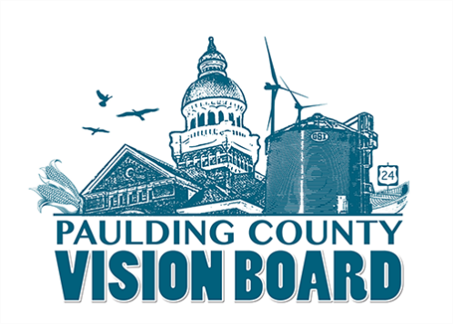
News Release:
Date: June 14th,2019
Contact: Erika Willitzer- Email: ewillitzer@ppec.coop or Cell: 419-769-3011

Paulding County’s Vision Board to Raise
$1 Million for Quality of Life Projects
  - EDP Renewables commits $25,000 toward countywide collaborative effort
(Paulding County, OH) The Paulding County Vision Board plans to launch their “Our Dream of a Million” campaign on Tuesday, July 23, at the Branch Fellowship Christian Church in Downtown Paulding, Ohio, at 7pm. The public is welcome to attend.
In a united front, Paulding County villages and townships identified quality of life projects to the tune of almost $300,000. These projects are to be implemented between 2019 -2023. The Vision Board doesn’t plan to fund the projects in their entirety. Communities will be responsible for most of the cost, but the hope is that by working together, they’ll be able to attract more grant and corporate dollars to assist the small communities and improve Paulding County overall.
“Our dream of raising a million is definitely a ‘WOW’ goal, but that’s what it is going to take if we truly want to make a difference in Paulding County and be able to attract and retain businesses and people in our county. We want to be a support system for all the communities and our hope is that “Our Dream of a Million” campaign will create a grassroots effort that will unite our county and elevate our quality of life,” stated Vision Board Member and Paulding Putnam Electric Economic Developer Erika Willitzer.
EDP Renewables graciously has already committed $25,000 toward the campaign, and they plan to do a matching grant of $3,000 for projects targeting parks and youth (This is limited to projects already submitted and approved by the board). “This type of investment will most definitely encourage and build a bigger grassroots effort throughout the county than we could have ever imagined,” added Willitzer.
According to Erin Bowser, Director of Project Management for EDP Renewables, the company wholeheartedly supports the Vision Board’s efforts. “EDP Renewables has been working with the Paulding County community for more than ten years. In that time, we have become invested not only in the county becoming the wind capital of the state but also in the health and growth of the entire community.” Bowser said. “We support the Vision Board, its members, and its mission because it aims to bring people together for a common purpose that will serve the entire community for generations to come.”
Currently the communities involved are as follows: Paulding County Townships Association, Paulding, Oakwood, Broughton, Antwerp, Payne, Latty, and Grover Hill. “We still have a few villages that are not participating, and we want them to know it’s still not too late,” said Dave Burtch, President of the Vision Board. “This is a collaboration, and we want to make sure everyone is included.”
So far, the identified projects are as follows:
- Antwerp: Riverside Park observation deck and updates to Hillside area
- Broughton: New playground equipment
- Grover Hill: New playground equipment at Welcome Park
- Payne: Creation of Buckeye Park
- Paulding: New soccer fields and lot at Lela McGuire Jeffery Park
- Oakwood: Project to be submitted soon
- Paulding County Project: Creation of Citizens Academy (Paulding Co. Sheriff’s Office)
- Paulding County Project: Mobile Hydraulic Stage for use at all outdoor events by county non-profits
- Paulding County Project: Creation of Downtown Improvement Program
- Paulding County Project: Countywide branding strategy
- Paulding County Project: Housing Study
Each project’s plan is being developed, and a summary of the project will be soon posted at www.PauldingCountyVisionBoard.com.
The Paulding County Vision Board’s mission is to coordinate collaboration, plan strategically, secure funding, and create a livable Paulding County community. The board was officially formed in 2018 and structured under the Paulding County Commissioners. Each village and the township association in Paulding county have a seat on the board.
Since 2018, the board, along with the help of Maumee Valley Planning, have identified goals and objectives through a comprehensive community development plan. The group surveyed each community and set a strategic plan for goals. Some villages have already, been allocated state grants for projects identified in the original comprehensive plan. (View plan at www.PauldingCountyVisionBoard.com)
Vision Board Member John Daeger (Broughton) and Quality of Life Committee Member Mark Greenwood (Antwerp), most recently took an in-depth look at our park and recreation assets. The goal is to create a website where Paulding County’s assets can be highlighted and use it as a tool to retain current residents and attract new residents or visitors.
An endowment fund has been established with the Paulding County Area Foundation; Vision Board members are asking that all community members rise up and take a firm stand on improving quality of life throughout Paulding County by contributing financially or volunteering for your local towns.
“The Vision Board has consistently demonstrated its ability to facilitate collaboration among our local villages. With this collaboration and the creation of a fund to be used to improve the quality of life, our community is going to thrive. Together everyone achieves more!” said, Paulding County Commissioner Tony Zartman.
“I love Paulding County-moving here was one of the best decisions my husband and I ever made,” said Willitzer. It’s safe, it’s picturesque, and the people here are my people. We embrace small-town life. But just because we live in rural America doesn’t mean we can just sit back and let everything take care of itself. There are areas in our communities that are economically depressed, and we need to work together to design a culture that people desire to be part of now and in the future for our children and grandchildren. We must work for it - and maybe even harder than in urban areas. Raising a million dollars may seem like a dream, but it’s something I think can become reality if we all work together,” stated Willitzer.
For more information on this initiative, visit www.PauldingCountyVisionBoard.com. If you plan to attend the public event on July 23 at the Branch Church in Paulding, please RSVP through the Vision Board’s Facebook page: www.facebook.com/PauldingCountyVision.
###

